PMAANZ MEETING 15/2/23

Carleen Craw-Thomson Riccarton Medical Practice 033488711

3:00-3:30pm Ethnicity Audits. This topic relates more to General Practice.

This is the link to MOH site. https://www.health.govt.nz/publication/primary-care-ethnicity-data-audit-toolkit all the following info is there.

Audit Tool Kit -39 pages.
https://www.health.govt.nz/system/files/documents/publications/primary_care_ethnicity_data_audit_toolkit_27_june.pdf

A Ethnicity Data Quality Audit Form for patient 2 pages
https://www.health.govt.nz/system/files/documents/publications/primary-care-ethnicity-data-audit-toolkit-patient-data-collection-form-16dec21.pdf

Compliance Audit Check List - 3 pages
https://www.health.govt.nz/system/files/documents/publications/primary-care-edat-ethnicity-data-systems-compliance-audit-checklist-16dec21.pdf

And form for Staff Survey - 4 pages
https://www.health.govt.nz/system/files/documents/publications/primary-care-ethnicity-data-audit-toolkit-staff-survey-form-16dec21.pdf

Assessment Form for staff audit -3 pages
https://www.health.govt.nz/system/files/documents/publications/primary-care-ethnicity-data-audit-toolkit-rapid-assessment-sheet-for-staff-surveys-16dec21.pdf

Ministry of health requirement to do this 3 yearly. see Ethnicity Data Protocols 2017 and Primary Care Ethnicity Data Audit Toolkit 2021.

There is a lot of information in the protocols and Tool kits.

Need to be completed 3 yearly. Page 3

It falls into The Equity Module 4.1 and also into Foundation 2.2 (enrolling patients consistent with current MOH guidelines)

Start with the Systems Compliance audit Checklists. (Practice assessment) to see where your gaps may be. Medtech 32 cannot be altered so some are out of your control. Page 6 -10

Followed by the Staff Survey. Page 11 - 16 I have seen some interesting responses over the years.
Assess the Staff Survey against the Rapid Assessment Sheet. Page 17 - 25 It will clearly identify any gaps. Provide Training as required.

Important to have access to the ethnicity data at the from desk so reception can find the appropriate level 4 (5 digit) for entering the ethnicity in the PMS. See the link below.
Other PMS may be easier to enter ethnicity codes.

http://aria.stats.govt.nz/aria/?_ga=2.199996458.547787243.1621201268-647135710.1590034663#ClassificationView:uri=http://stats.govt.nz/cms/ClassificationVersion/l36xYpbxsRh7IW1p Good to save this to favorites.

STATS NZ website

Go to Classifications - search “Ethnicity”

Select - Ethnicity NZ Standard Classifications 2005 V2.1.0
Use the Browse Tab – can use the search button on the right of the screen to search a country for ethnicity code.

Can click on each of the 9 categories and break them down to the full 5-digit codes
e.g., 4 Asian, 42 Chinese, 421 Chinese, 41112 Cambodian Chinese

See Screen Shots below.

Ethnicity data quality audit Page 26 – 34 Use the standardised form (use the link attached).
Can be given to the patient to fill out while in the practice. Set your number to print and have a collection box. What percentage of patient numbers do you want to survey? I did 120 forms.
Can be posted -If you have to.
Can be emailed- if you want to.
Collating is straight forward again just follow the instructions – assess the information and you will find if you are doing really well or if there is an area that needs more training.

Once you have all the information you can complete your report for discussion with staff.
These are the headings I use:
Date of audit
Background
Process
Results of Audit (in Table format) and narrative
Breakdown of Respondent Ethnicity and Population (in Table format)
Findings
Taking action
References.

You can do your report any way that works for you and your practice.

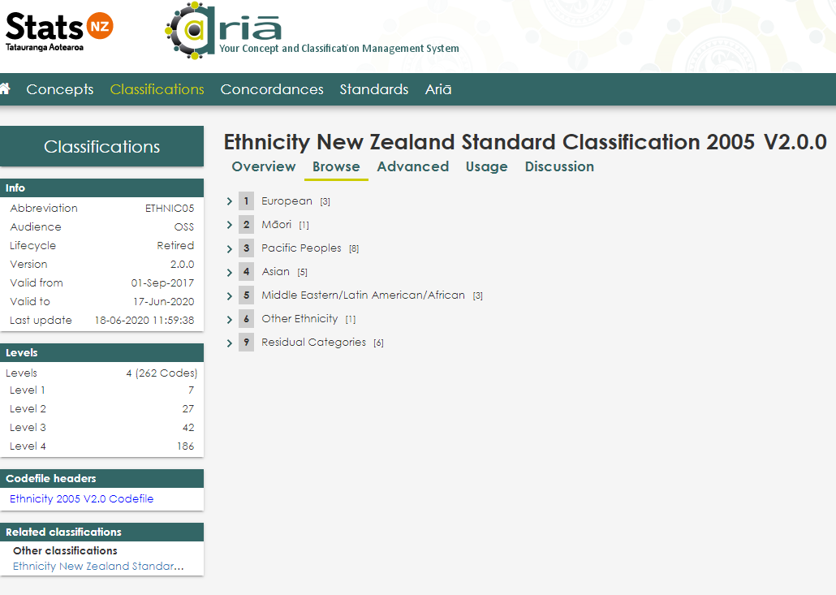

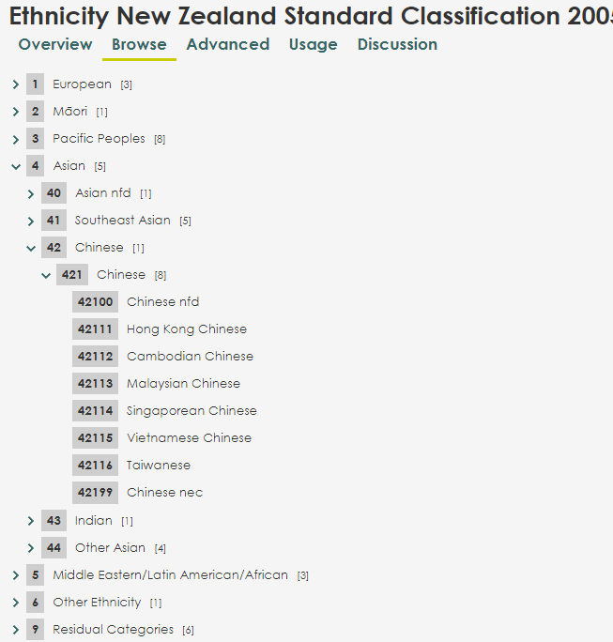
Example above showing the graduation from Asian at (4) to Singapore Chinese at (42114)

Search button on the right of the screen
