Subject line: Now you are [turning] 65, it’s the best time to protect yourself against shingles

Body copy:

Kia ora <name>

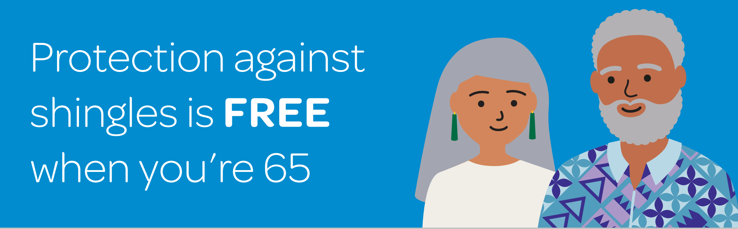

Now is a great time to ask your doctor about getting vaccinated against the shingles virus.

What is shingles?
Shingles is a painful skin rash, caused by the same virus that causes chickenpox. If you have ever had chickenpox, the virus stays in your body and becomes dormant. Later, if the virus becomes active again, it is called shingles.

Why get vaccinated?
The risk of getting shingles increases as you get older, and your best protection is to get vaccinated.

The vaccine, Shingrix, is free for everyone in the year they are 65. You’ll need two doses, two to six months apart. If you get your first dose while you are 65, both doses are free. If you get your first dose after you turn 66, you will need to pay for the full course.

Where to get vaccinated
Next time you visit your GP or medical centre, arrange to have your shingles vaccination at the same time. If you don’t have an upcoming appointment, give them a call and make a booking. And, while you’re there, it’s a good time to check that you are up to date with all your vaccinations. [If you’re not enrolled with a GP or medical centre, discuss this with a centre convenient to you.]

To find out more about getting vaccinated for shingles, visit health.govt.nz/shingles or call Healthline on 0800 611 116.

Ngā mihi,

Te Whatu Ora Health New Zealand

